Module 3 — Modern JavaScript Data Dashboard
MCON 505: Front-End Frameworks

GitHub Repository
https://github.com/GrossAri/mcon505-front-end-frameworks/tree/main/module-03-modern-js-dashboard

Description
A vanilla JavaScript dashboard built with Vite that retrieves user data from the JSONPlaceholder API and displays it with modern ES6+ features. The module folder contains:
- Source files: src/main.js, src/api.js, src/utils.js, src/style.css, and index.html
- README.md with setup instructions and a feature overview
- AI_USAGE.md (AI usage disclosure)
- Screenshots of the running application (also shown below)

Features Demonstrated
- Modules: import/export across api.js, utils.js, and main.js
- Arrow functions, object destructuring, and template literals
- Array methods: map() for usernames, filter() for usernames containing "e", reduce() for total username characters
- Spread operator: copied the users array and added a custom user (new count: 11)
- async/await with the Fetch API and try/catch error handling

Screenshots
1. Running application
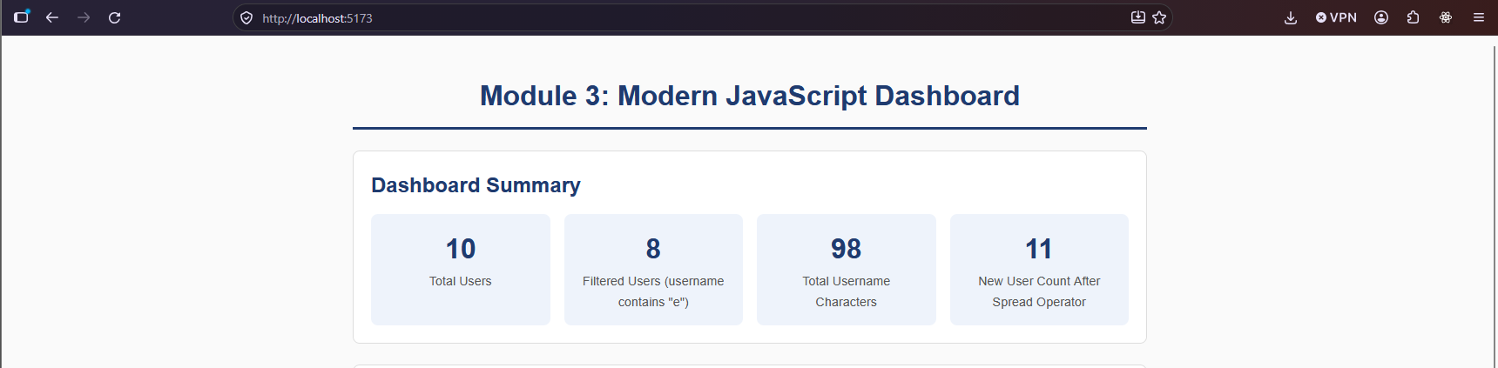
2. User data displayed
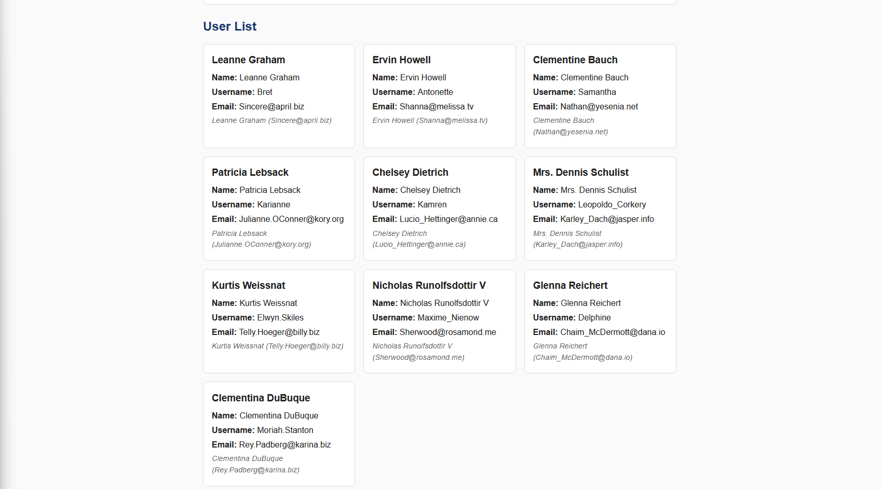
3. Summary statistics and array method results
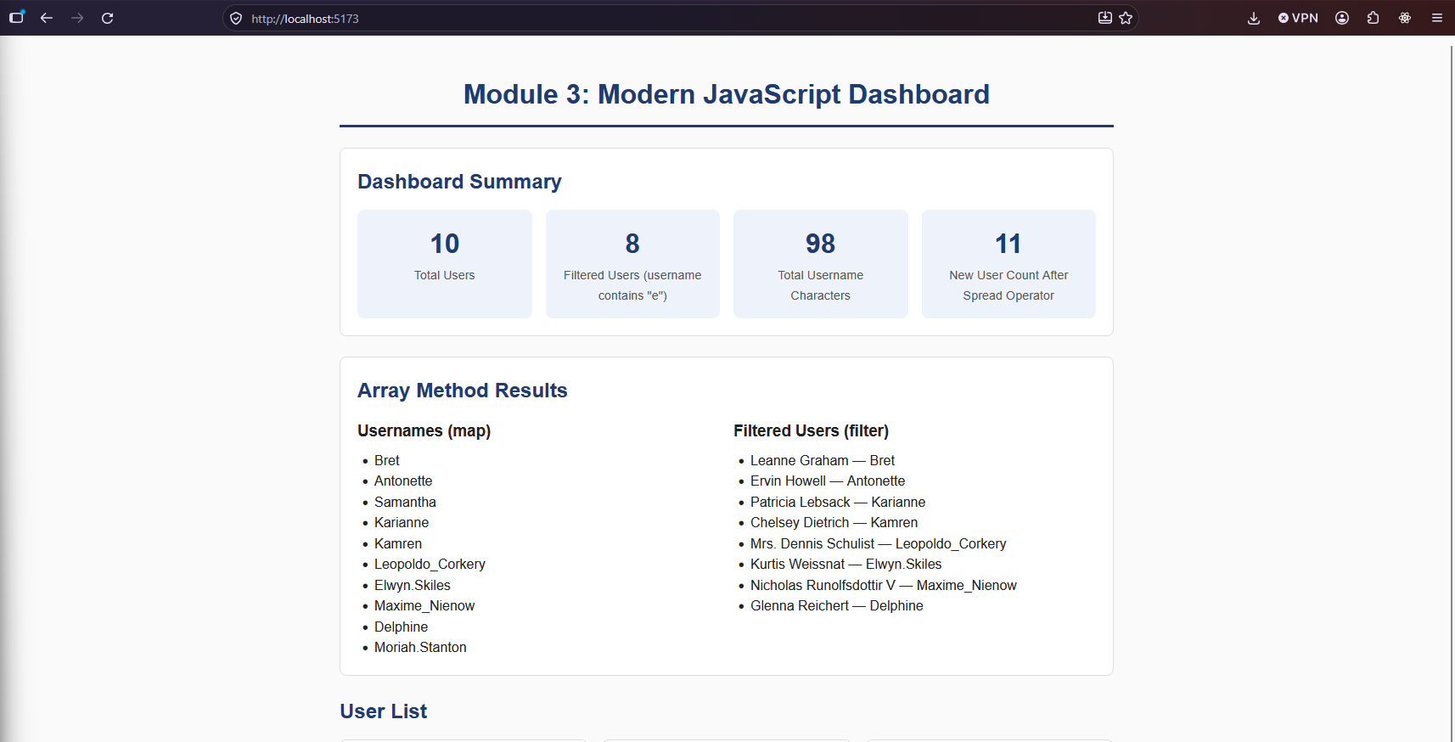
4. Browser Developer Tools Console with no errors


